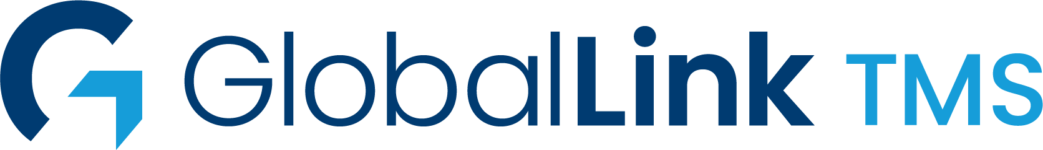

Intelligent, scalable solutions that drive growth and deliver results wherever your content lives.
GlobalLink TMS helps streamline the process of managing complex localization requirements for both online and offline content.
GlobalLink TMS provides powerful business process automation, flexible integration capabilities, translation vendor management and project workflow capabilities in an intuitive, web-based platform.
GlobalLink TMS is also a vendor-agnostic AI Marketplace. Our AI Consulting team can help design strategies to optimize any combination of TransPerfect and third party, trained and untrained Neural MT and LLM.
AI is used throughout the platform both to enhance the User Experience and automation by using Agents.


Key Advantages
SEAMLESS DATABASE INTEGRATION
Use GlobalLink Connectors with any CMS, PIM, CCMS, or e-commerce platform
VENDOR-NEUTRAL PLATFORM
Allow access to any vendor or internal translator for maximum resource flexibility
WORK WITH ANY FILE FORMAT
Next-generation parsing engines extract content and prepare it for translation
CONFIGURABLE WORKFLOW
Streamline your translation process through automation of manual tasks
TRANSLATION MEMORY INTEGRATION
Maintain brand consistency and save on repeat translations
ENTERPRISE REPORTING
View virtually any set of data points in real time to gauge translation efficiency
UNIFIED DASHBOARD
Track all projects in real time across the enterprise so you never miss a deadline
FLEXIBLE DEPLOYMENT MODELS
Install on-premise or deploy in the cloud without sacrificing functionality

